Kingdom of Bahrain
Primary Healthcare Centers
Naraak
Phase 6: Flutter Demonstration Prototype
Prepared by
Fatima Yaser Darraj
Eman Yaser Alasaadi
Alya Hasan Aldaka
IT Trainees
Submitted to
Mohamed Ateya Neama
Fatema Isa Nooh
Date: [To be filled at submission]

Document Control

Version History
Version | Date | Author | Change Description
0.1 |  | IT Trainee Team | Initial Phase 6 template with project structure, mock data strategy, and worked code examples; pending Phase 5 sign-off

Approval / Sign-off
Role | Name | Signature | Date
Project Supervisor | Mohamed Ateya Neama
Project Supervisor | Fatema Isa Nooh
PHC/MOH Stakeholder | Mohamed Khalil

1. Purpose of This Phase
Phase 6 implements the validated Phase 4 UI/UX designs as a working Flutter prototype (mobile and web) using dummy data, to demonstrate the proposed user experience end-to-end. Per the approved proposal, this phase does not include production backend integration.
Inputs required before finalizing this document:
- Phase 4 high-fidelity Figma screens and design tokens
- Phase 5 API field definitions (used to shape the dummy data models, so structure matches the future real API)
TO COMPLETE: confirm Phase 5 sign-off status and version referenced here.
SCOPE LIMIT: this build must remain dummy-data only. No live eKey authentication, no real RMS/MOH database calls, no production credentials. All data shown must be clearly fictional (placeholder names, fake CPRs) to avoid any confusion with real patient data during demos.

2. Prototype Architecture (Dummy-Data Mode)
Instead of a live API Gateway, the Flutter app calls a local Mock Data Service that returns data shaped exactly like the Phase 5 API specification. This means swapping in a real backend later is a mechanical replacement of the mock service layer, not a redesign.
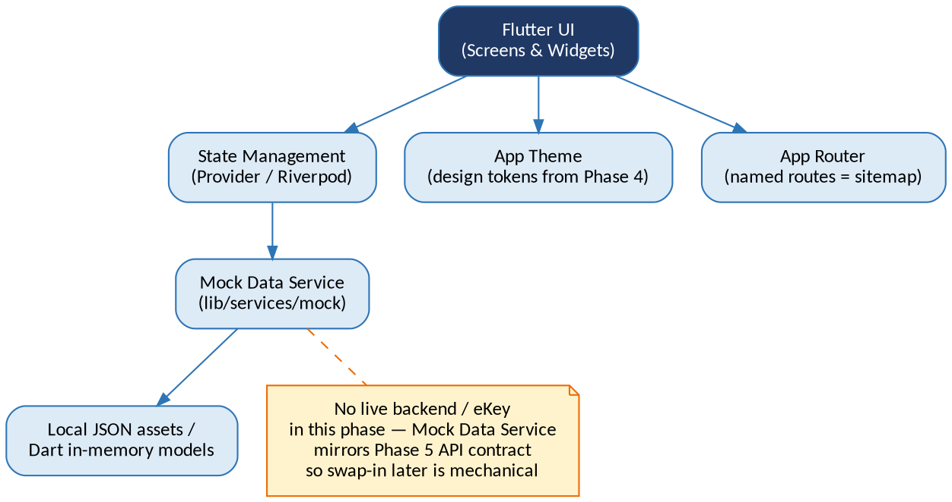
Figure 1: Naraak Flutter prototype architecture — dummy-data mode

3. Project Structure
Suggested folder structure to keep screens, mock data, and theming cleanly separated:
lib/
main.dart
theme/
app_colors.dart // Phase 4 palette as constants
app_text_styles.dart // Phase 4 typography scale
app_theme.dart // ThemeData combining both
routes/
app_router.dart // named routes = Phase 3 sitemap
models/
appointment.dart
vaccination_record.dart
service_request.dart // shared shape for Hajj/Fee Exemption/etc.
services/
mock/
mock_appointment_service.dart
mock_vaccination_service.dart
mock_profile_service.dart
...one per service area, matching Phase 5 endpoints
screens/
home/home_screen.dart
appointments/appointments_list_screen.dart
appointments/appointment_confirm_screen.dart
...one folder per service, matching Phase 4 screen names
widgets/
app_card.dart
app_button.dart
status_badge.dart
empty_state.dart
data/
mock_appointments.json
mock_vaccinations.json
...one JSON asset per service, or Dart const lists

4. Design Token Mapping (Theme)
Phase 4 design tokens translate directly into a Flutter theme file, so screens automatically stay visually consistent:
// lib/theme/app_colors.dart
class AppColors {
static const primaryNavy = Color(0xFF1F3864);
static const primaryBlue = Color(0xFF2E75B6);
static const accentTeal = Color(0xFF2AA198);
static const success = Color(0xFF2E7D32);
static const warning = Color(0xFFED6C02);
static const error = Color(0xFFC62828);
static const neutral900 = Color(0xFF1A1A1A);
static const neutral500 = Color(0xFF6B6B6B);
static const neutral100 = Color(0xFFF4F6F8);
}
TO COMPLETE: update these hex values once the Phase 4 palette is finalized, and add the confirmed font family to app_text_styles.dart.

5. Mock Data Strategy
Each service's mock service class returns data shaped exactly like its Phase 5 API response, with a simulated network delay (e.g., 400-800ms) so loading states can be demonstrated realistically.

5.1 Worked Example: Booking Appointments
// lib/services/mock/mock_appointment_service.dart
class MockAppointmentService {
Future<List<Appointment>> getAvailableSlots({
required String centerId,
DateTime? date,
}) async {
await Future.delayed(const Duration(milliseconds: 600));
return mockAppointmentSlots; // from data/mock_appointments.json
}
Future<Appointment> bookSlot(String slotId) async {
await Future.delayed(const Duration(milliseconds: 500));
return Appointment(
id: 'apt_${DateTime.now().millisecondsSinceEpoch}',
status: 'confirmed',
);
}
}

5.2 Mock Data Coverage by Service
Service | Mock Data Source | States to Cover
Booking Appointments |  | Success / Empty / Error
Vaccination Records & Certificate |  | Success / Empty / Error
Medical Reports & Certificates |  | Success / Empty / Error
Sehati Card Request for Newborns |  | Success / Empty / Error
Electronic Hajj Certificate |  | Success / Empty / Error
Update Residential Address |  | Success / Empty / Error
Health Fee Exemption Card Issuance |  | Success / Empty / Error
Request Mobile Unit Service |  | Success / Empty / Error
Mammogram Appointment Requests |  | Success / Empty / Error
Change Family Doctor |  | Success / Empty / Error
Primary Healthcare Research Applications |  | Success / Empty / Error
Tele-Appointment Instructions |  | Success / Empty / Error
TO COMPLETE: fill in the Mock Data Source column (JSON asset filename or Dart const list) as each service is implemented, and confirm every service demonstrates at least a success, empty, and error state — this is what makes the demo credible rather than a single happy-path click-through.

6. State Management
Recommend a single, lightweight state management approach across the whole prototype rather than mixing patterns, to keep the codebase approachable for a 3-person trainee team on a 1-week phase.
Option | Fit for This Project
Provider | Simplest to learn, sufficient for dummy-data screens with no complex async chains. Recommended default.
Riverpod | More robust and testable, slightly steeper learning curve; consider if team already has React/state-management experience.
Bloc | Likely overkill for a 1-week dummy-data demo; adds boilerplate not justified at this scope.
TO COMPLETE: confirm the team's choice here before implementation starts, and use it consistently across all screens.

7. Navigation & Routing
Named routes should map 1:1 to the Phase 3 sitemap, so the prototype's navigation structure is traceable back to the approved information architecture.
// lib/routes/app_router.dart (excerpt)
'/splash' -> SplashScreen
'/login' -> EkeyLoginScreen (simulated)
'/home' -> HomeDashboardScreen
'/services' -> ServicesListScreen
'/services/appointments' -> AppointmentsListScreen
'/services/appointments/confirm' -> AppointmentConfirmScreen
'/profile' -> ProfileScreen
'/family' -> FamilyManagementScreen
'/feedback' -> FeedbackScreen

8. Consent & Privacy-by-Design Demonstration
Per the approved proposal, consent screens and privacy-by-design flows must be demonstrable within the prototype, even though no real data processing occurs. Include:
- A consent screen shown before eKey login (simulated) explaining what data the app will access.
- A consent step before granting a family member access to another profile.
- A clear data-usage notice on any screen collecting sensitive health data (e.g., Fee Exemption document upload, Research Applications).
TO COMPLETE: confirm exact consent copy with the team/supervisors; keep it short and in both Arabic and English.

9. Platform Targets & Testing
Platform | Target | Test Checklist
Mobile | Android + iOS (Flutter mobile build) | Layout at common screen sizes; RTL Arabic layout; touch target sizing
Web | Flutter web build, responsive breakpoints | Layout at desktop + tablet widths; keyboard navigation; RTL Arabic layout

10. Demo Script / Walkthrough
Suggested click-through sequence for presenting the prototype to Project Supervisors and PHC/MOH stakeholders:
- 1. Splash & simulated eKey login, showing the consent screen.
- 2. Home dashboard, highlighting the consolidated PHC-only navigation (resolving the core Phase 1 problem statement).
- 3. Booking Appointments — full happy path: search, filter, book, confirm, view in My Appointments.
- 4. One flagged-service walkthrough — Electronic Hajj Certificate — showing the clearer staged status (submission / eligibility / generation / download), resolving its Phase 1 failure pattern.
- 5. Family Management — adding/switching between family member profiles with the consent step.
- 6. An intentional error state (e.g., no slots available) to show the friendly fallback messaging from Phase 5 Section 4.
- 7. Language switch to Arabic, showing RTL layout on at least two screens.

11. Known Limitations of This Phase
SCOPE LIMIT: no live backend, no real eKey integration, no real PHC/MOH data connectivity. All data is fictional dummy data for demonstration only. This is explicitly the scope boundary agreed in the approved project proposal, and should be stated up front in any demo or presentation to avoid stakeholders mistaking it for a production-ready system.

12. Phase 6 Deliverables Checklist
- [ ] Project structure set up (theme, routes, models, mock services, screens, widgets)
- [ ] Design tokens implemented from Phase 4
- [ ] Mock data implemented for all MVP-tier services (success/empty/error states)
- [ ] Navigation wired to match Phase 3 sitemap
- [ ] Consent / privacy-by-design screens implemented
- [ ] Mobile build tested (Android + iOS)
- [ ] Web build tested (responsive)
- [ ] Arabic RTL verified on key screens
- [ ] Demo script rehearsed by the team
- [ ] Reviewed internally by all three trainees
- [ ] Submitted to Project Supervisors for sign-off
- [ ] Final presentation delivered to PHC/MOH stakeholders

